**VISVESVARAYA TECHNOLOGICAL UNIVERSITY**

Jnana Sangama, Belagavi, Karnataka - 590018

**DEPARTMENT OF COMPUTER SCIENCE ENGINEERING**



A Project Report on

**AGRO VISION: Agricultural Intelligence System for Predictive Price Analytics**

Submitted in partial fulfilment of the requirements for the conferment of degree of

**BACHELOR OF ENGINEERING**

in

**COMPUTER SCIENCE AND ENGINEERING**

by

**RAKSHITHA L N 1BY22CS142**

**REYYAN ALEEM JANBAZ 1BY22CS146**

**SARIKA S SURA 1BY22CS162**

**SWITHIN FERNANDES 1BY22CS184**

Under the Guidance of

**Prof. Tanishq Nanda**

ASSISTANT PROFESSOR

Department of CSE, BMSIT&M



**BMS INSTITUTE OF TECHNOLOGY AND MANAGEMENT**

(Autonomous Institute under VTU, Belagavi, Karnataka - 590 018)

Yelahanka, Bengaluru, Karnataka - 560119

**BMS INSTITUTE OF TECHNOLOGY AND MANAGEMENT**

(Autonomous Institute under VTU, Belagavi, Karnataka - 590 018)

Yelahanka, Bengaluru, Karnataka – 560119

### DEPARTMENT OF COMPUTER SCIENCE AND ENGINEERING



**CERTIFICATE**

This is to certify that the Mini-Project work entitled **“AGRO VERSION: Agricultural Intelligence System for Predictive Price Analytics”** is a Bonafide work carried out by **Rakshitha LN(1BY22CS142), Reyyan Aleem Janbaz (1BY22CS146), Sarika S Sura(1BY22CS162), Swithin Fernandes (1BY22CS181),** in partial fulfillment for the award of **Bachelor of Engineering Degree in Computer Science and Engineering** of the **Visvesvaraya Technological University, Belagavi** during the year 2025-2026. It is certified that all corrections/suggestions indicated for Internal Assessment have been incorporated in this report. The Mini-Project report has been approved as it satisfies the academic requirements in respect of Mini-Project work for B.E. Degree.

Signature of the Cluster Head

Dr. Radhika R

Associate Professor & Associate Head

Department of Computer Science

Signature of the Guide

Prof. Tanishq Nanda

Assistant Professor

Department of Computer Science

Signature of the Principal

Dr.SANJAY H A

Principal

BMSIT&M, Bengaluru

Signature of the HoD

Dr. Satish Kumar T

Professor and HoD

Department of CSE

**External VIVA-VOCE**

Name of the examiners Signature with Date

**1.**

**2**

**ACKNOWLEDGEMENT**

I would like to express my heartfelt gratitude to everyone who has contributed to make this project a memorable experience and has inspired this work in some way. Let me begin by expressing mny gratitude to the Almighty God for the numerous blessings he has bestowed upon me.

We are happy to present this project after completing it successfully. This project would not have been possible without the guidance, assistance and suggestions of many individuals. We would like to express our deep sense of gratitude and indebtedness to each and every one who has helped us make this project a success.

We heartily thank **Dr. Sanjay H A**, Principal, BMS Institute of Technology & Management for his constant encouragement and inspiration in taking up this Project.

We heartily thank **Dr. Satish Kumar T**, HoD, Department of Computer Science, BMS Institute of Technology & Management for her constant encouragement and inspiration in taking up this project.

We heartily thank **Dr. Radhika R,** Cluster Head, BMS Institute of Technology & Management for his constant encouragement and inspiration in taking up this project.

We gracefully thank our Project guide, **Prof. Tanishq Nanda** throughout the course of the Project work.

Special thanks to all the staff members of Information Science Department for their help and kind co-operation.

Lastly, we thank our parents and friends for their encouragement and support given to us in order to finish this precious work.

**Rakshitha L N (1BY22CS142)**

**Reyyan Aleem Janbaz (1BY22CS146)**

**Sarika S Sura(1BY22CS162)**

**Swithin Fernandes(1BY22CS184)**

# ABSTRACT

# Agro Vision is an agricultural intelligence platform designed to provide real-time crop price insights, historical trend analysis, and AI-driven price predictions for farmers, merchants, and consumers. The system integrates interactive dashboards, region-based filtering, and a lightweight prediction model to simplify decision-making in a highly fluctuating market. Users can explore factors influencing price changes, access crop-specific news, and receive guidance through an integrated chatbot. By combining data visualization with intelligent analytics, Agro Vision offers a unified, user-friendly solution that enhances transparency, supports better market decisions, and bridges the information gap in agricultural pricing.

**DECLARATION**

We, hereby declare that the project titled “ **“AGRO VERSION: Agricultural Intelligence System for Predictive Price Analytics”**”is a record of original project work under the guidance of **Prof Tanishq Nanda,** Department of Computer Science Engineering BMS Institute of Technology & Management, Autonomous Institute under Visvesvaraya Technological University, Belagavi during the Academic Year 2025-2026.

I also declare that this project report has not been submitted for the award of any degree, diploma, associate ship, fellowship or other title anywhere else

|  |  |  |
| --- | --- | --- |
| **Name of the Student** | **USN** | **Signature** |
| **RAKSHITHA L N** | **1BY22CS142** |  |
| **REYYAN ALEEM JANBAZ** | **1BY22CS146** |  |
| **SARIKA S SURA** | **1BY22CS162** |  |
| **SWITHIN FERNANDES** | **1BY22CS184** |  |

# TABLE OF CONTENTS

# DECLARATION i

# ABSTRACT ii

Chapter 1: Introduction 01

* 1. Background 02
  2. Literature Survey .03
  3. Motivation .06
  4. Problem Statement .07
  5. Aim and Objectives .08
  6. Scope .09
  7. Challenges .09

Chapter 2: Overview 11

Chapter 3: Requirement Specification 12

* 1. Functional Requirements 12
  2. Non Functional Requirements 12
  3. Software Requirements 13
  4. Hardware Requirements 13
  5. System Requirements 14
  6. Constraints 14

Chapter 4: Detailed Design 15

* 1. System Architecture 15
  2. Class Design 16
  3. Sequence Diagram 17

Chapter 5: Implementation 18

* 1. Programming Language 18
  2. Algorithms 19
  3. Proposed Design 20
  4. Code Snippets 20

Chapter 6: Testing… 23

* 1. Test Objectives 23
  2. Testing Phases … 23
  3. Test Validation 23

Conclusion and Future Enhancements 32

References 35

# LIST OF FIGURES

| **Figure No.** | **Figure Caption** | **Page No.** |
| --- | --- | --- |
| Figure 1 | Three-tier system architecture of AgroVision showing the Presentation Layer (Frontend UI), Application Layer (Backend/API), and Data Layer (Database & External Integrations) | 18 |
| Figure 2 | High-level architecture diagram illustrating the interaction between User Interface, Backend API Services, Database, and External API integrations (Weather, News, and Chatbot services) | 19 |
| Figure 3 | Use case diagram depicting the interactions between different actors (Farmer, Merchant, Customer) and core system functionalities including dashboard viewing, crop details access, region filtering, and chatbot assistance | 21 |
| Figure 4 | Level-0 Data Flow Diagram (Context Diagram) showing the AgroVision system as a central entity interacting with users and external data sources | 22 |
| Figure 5 | Level-1 Data Flow Diagram showing detailed processes including Dashboard Data Fetching, Crop Details Display, Price Prediction Generation, and Chatbot Response handling with their respective data flows | 23 |
| Figure 6 | System architecture flowchart illustrating the complete data flow from user request through frontend components, backend processing, database queries, and external API calls to final response delivery | 24 |
| Figure 7 | Flowchart for viewing crop details showing the sequential process from user crop selection through data retrieval, chart rendering, prediction display, and news integration | 25 |
| Figure 8 | Flowchart for AI chatbot interaction depicting the process flow from user query submission through context extraction, LLM API communication, and response generation | 26 |
| Figure 9 | Implementation overview diagram showing the technology stack including React JS frontend, Node.js backend, PostgreSQL database, and integration of ML models and external APIs | 31 |
| Figure 10 | Frontend folder structure showing the organization of React components, services, utilities, and assets in the project directory | 33 |
| Figure 11 | Code snippet demonstrating the dashboard implementation for fetching and displaying crop data with price information and trend indicators | 34 |
| Figure 12 | Code implementation example of the interactive historical price chart using Recharts library with dynamic data rendering | 35 |
| Figure 13 | Backend API implementation code for the prediction panel showing the endpoint structure for fetching AI-generated price predictions | 35 |
| Figure 14 | Chatbot implementation code demonstrating the message handling logic and API integration for conversational AI responses | 36 |
| Figure 15 | Screenshot of the AgroVision mobile application interface showing the crop dashboard with price cards and navigation elements | 37 |
| Figure 16 | Backend folder structure displaying the organization of routes, controllers, services, models, and configuration files | 37 |
| Figure 17 | Unit testing interface showing test cases for crop data retrieval, chart rendering, and prediction logic validation | 44 |
| Figure 18 | Cross-platform testing results displaying AgroVision interface across different devices including mobile phones, tablets, and desktop browsers demonstrating responsive design implementation | 53 |

# LIST OF TABLES

| **Table No.** | **Table Caption** | **Page No.** |
| --- | --- | --- |
| Table 1 | Actor roles and descriptions in the AgroVision system showing the three primary user types and their objectives | 20 |
| Table 2 | Crops database table schema defining fields for crop identification, categorization, and basic information storage | 27 |
| Table 3 | Price History database table schema showing the structure for storing historical crop price data with temporal and regional attributes | 27 |
| Table 4 | Factors database table schema illustrating the storage structure for market influencing factors and their impact scores on crop prices | 28 |
| Table 5 | News database table schema defining the structure for storing crop-related news articles with metadata and publication details | 28 |
| Table 6 | Test case summary showing the description, expected results, and pass/fail status for key system functionalities including dashboard load, search, charts, predictions, filters, chatbot, and news integration | 47 |

**Chapter 1**

**INTRODUCTION**

Agriculture remains one of the most essential sectors in developing economies, providing livelihood, food security, and raw materials for industries. However, despite its importance, the agricultural market is largely unorganized and unpredictable. Price variations, climatic uncertainties, and market discrepancies often result in financial losses for farmers and inefficiencies in the supply chain. With the rise of digital technologies, data analytics, and artificial intelligence, there exists an opportunity to build systems that enable informed decision-making for all agricultural stakeholders—farmers, merchants, and consumers.

The project titled “Agricultural Intelligence System for Predictive Price Analytics and Crop Threat Detection” aims to bridge this gap by building a unified digital platform—AgroVision—that transforms traditional, intuition-based market participation into data-driven decision-making. The system provides real-time price updates, historical data visualizations, AI-generated predictions, and intelligent assistance through an integrated chatbot. By combining multiple modern technologies, AgroVision seeks to make agriculture more transparent, predictable, and accessible.

* 1. **BACKGROUND**

Agricultural markets are influenced by multiple interdependent factors, including seasonal variations, weather patterns, pest outbreaks, transportation costs, government policies, import-export regulations, and global commodity prices. This complexity makes it difficult for stakeholders to accurately estimate the value of a crop at any given time. Traditionally, farmers access market price information through local traders, informal networks, or outdated reports. This lack of reliable, real-time data often leads to poor pricing decisions, forcing farmers to sell below the fair market rate. Merchants face a different challenge—they need to understand price variations across regions to optimize procurement and distribution strategies. Consumers, meanwhile, experience fluctuating retail prices and have limited knowledge of the reasons behind these changes.With the evolution of cloud computing platforms, mobile applications, and AI-based forecasting models, it has now become possible to centralize large amounts of agricultural data and present them in user-friendly formats. Modern technologies make it feasible to show market behavior in the same way financial platforms visualize stock price trends. AgroVision uses this technological shift to bring sophistication and intelligence to agricultural commerce.

* 1. **LITERATURE SURVEY**

Numerous studies and systems emphasize the role of digitalization in agriculture. Government portals report daily agricultural prices, but they lack real-time updates, predictive analytics, and role-based customization. Research papers highlight the use of machine learning algorithms like ARIMA, LSTM, and regression models for agricultural price forecasting. Studies on precision agriculture explore the use of satellite imagery, weather models, and IoT data for predicting crop health and yields.

Existing applications such as e-NAM, Agmarknet, and Kisan Suvidha focus primarily on static price reporting or agricultural advisories. While helpful, they do not provide interactive data visualizations, historical trends, or AI-based predictions. Moreover, they lack role-specific interfaces tailored to farmers, merchants, or consumers. Few systems integrate an explainable AI layer that helps users understand why prices are rising or falling.

Recent research emphasizes the need for decision-support systems that combine data visualization with predictive analytics. However, no current system offers a stock-market-like dashboard for crops, along with an intelligent, page-aware chatbot capable of summarizing data and answering queries in real time. This gap in existing literature supports the need for a modern, intelligent, multi-client agricultural analytics platform.

* 1. **MOTIVATION**

Agricultural stakeholders face several challenges that motivated the development of AgroVision:

### ****For Farmers****

* Lack of reliable, accurate, and real-time market information.
* Dependence on intermediaries for price insights.
* Difficulty identifying the best time to sell to maximize profits.
* Limited knowledge about market trends and influencing factors.

### ****For Merchants****

* Difficulty tracking regional price variations.
* Inability to analyze historical and predicted price movements.
* Challenges in planning procurement and distribution efficiently.

### ****For Consumers****

* Fluctuating retail prices with little transparency.
* Lack of understanding about seasonal availability and price cycles.

The motivation behind AgroVision is to create a platform that eliminates guesswork and provides transparency through predictive analytics, easy-to-read charts, and an AI assistant. By presenting agricultural data the same way financial markets present stocks, AgroVision aims to empower every user to make informed, data-driven decisions.

* 1. **PROBLEM STATEMENT**

The agricultural market in India continues to operate with limited transparency, leaving farmers, merchants, and consumers without reliable information to make informed decisions. Farmers often depend on middlemen or fragmented sources for price updates, leading to financial losses and poor timing in the sale of their produce. Merchants struggle to analyze regional price variations and plan procurement effectively, while consumers remain unaware of the factors influencing daily price fluctuations. Although several platforms offer basic price listings, none provide an integrated system that combines real-time market insights, historical trend visualization, predictive price analytics, and contextual guidance through an intelligent assistant. There is a clear need for a unified, accessible, and data-driven solution that simplifies agricultural decision-making for all stakeholders. **AgroVision aims to bridge this gap by delivering a comprehensive platform that brings transparency, predictability, and clarity to agricultural pricing.**

* 1. **AIM AND OBJECTIVE**

**Aim:**

The primary aim of this project is to develop *AgroVision*, an intelligent and user-friendly agricultural information system that helps farmers, merchants, and consumers understand market prices, track historical trends, and make better decisions through AI-assisted predictive analytics.

**Objectives:**

1. Design a unified platform presenting real-time crop prices with clear, accessible dashboards for all user groups.
2. Enable deep market understanding through interactive visualizations, historical trend analysis, and identification of factors like weather, supply variations, seasonal cycles, and policy changes.
3. Incorporate intelligent assistance by integrating an AI-based price prediction module and a conversational chatbot for guidance, summaries, and query support.
4. Deliver a tailored, responsive web application offering role-specific insights for farmers, merchants, and consumers, optimized for easy demonstration and real-world use.
   1. **SCOPE**

The scope of AgroVision encompasses the design, development, and deployment of a complete web-based agricultural intelligence system that serves three major user groups: farmers, merchants, and consumers. The system focuses on providing a transparent, data-driven understanding of crop markets by combining real-time price information, historical analysis, and AI-assisted predictions. Within the boundaries of this project, the platform includes a visually intuitive dashboard showcasing current crop prices, role-based insights, and region-specific filtering to make the information relevant and actionable for each type of user.

The project also covers the integration of interactive charts that allow users to explore market trends over varying time periods, helping them analyze price movements in a stock-market-like interface. Another significant part of the scope is the incorporation of an AI prediction module that estimates future crop prices based on trends, seasonal behavior, and other external factors. To deepen market understanding, the system presents a curated list of influencing factors—such as weather conditions, supply fluctuations, and policy updates—that help users interpret why prices rise or fall.

Additionally, the system features a built-in AI chatbot that remains accessible on every page, offering contextual explanations, summarizing information, and guiding users through the platform. This enhances usability, especially for individuals unfamiliar with technical data. The project scope also includes collecting and displaying crop-specific news articles so users can stay updated on events impacting market conditions.

Overall, the scope covers all essential components required to build a functional, responsive, and user-friendly prototype suitable for academic demonstration. However, the scope does not extend to creating a fully automated real-time data pipeline, satellite-based crop threat detection, or advanced deep learning prediction models—these remain areas for future enhancement.

### CHALLENGES

Developing *AgroVision* presented several practical and technical challenges due to the complex and dynamic nature of agricultural markets. One of the primary challenges was the inconsistency and limited availability of structured, real-time agricultural price data. Since crop prices vary across regions and depend on multiple external factors, gathering clean and reliable datasets required careful filtering and preprocessing. Additionally, predicting agricultural prices is inherently difficult, as they are influenced by unpredictable variables such as sudden weather changes, transportation disruptions, pest outbreaks, and government announcements.

Designing an interface that could comfortably serve three different user groups—farmers, merchants, and consumers—posed another challenge. Each group has unique expectations and varying levels of digital familiarity, especially farmers, who may not always be accustomed to complex data dashboards. Ensuring that the system remained intuitive, visually clear, and easy to navigate on both mobile phones and larger screens required thoughtful UI and UX decisions.

Integrating multiple components—such as charts, prediction models, region filters, news updates, and the AI chatbot—into one cohesive platform also demanded careful coordination. Maintaining performance while loading large datasets, rendering charts, and generating predictions without delays was a continuous concern. Finally, ensuring the chatbot stayed context-aware and useful across all pages required additional design considerations to avoid confusion or irrelevant responses.

**Chapter 2**

**OVERVIEW**

Agro Vision is designed as a comprehensive digital platform that brings clarity, structure, and intelligence to the agricultural market. At its core, the system aims to simplify the way farmers, merchants, and consumers understand crop prices by presenting data in a visually intuitive and meaningful form. Instead of relying on scattered information sources or traditional market reports, users of Agro Vision gain access to a unified interface that mirrors the clarity and analytical depth of modern financial dashboards.

The system integrates several key components—real-time price display, historical trend analysis, AI-powered price predictions, and factor-based insights—into a single cohesive environment. By combining these features, Agro Vision helps users understand not just *what* the current price is, but also *why* it is changing and *how* it may behave in the coming days. This holistic approach is what makes the platform more than a simple market information tool; it becomes a decision-support system.

To support different types of users, Agro Vision is built with a multi-role structure. Farmers can check selling prices and identify the best possible time to take their produce to market. Merchants can compare prices across regions to make smarter procurement and distribution decisions. Consumers can examine seasonal trends and get a clearer view of retail fluctuations. Each role sees the same data through a different lens, making the system flexible and user-centred.

At the architectural level, Agro Vision follows a modular and scalable design, consisting of a modern web-based frontend, a backend service layer for data processing, and a database/external data integration layer. The system interacts with third-party services such as news APIs and weather information providers to offer richer context around market changes. Historical price databases and prediction models work together to deliver insights that would otherwise be difficult to uncover through manual observation.

Agro Vision also incorporates an intelligent chatbot that acts as a personal assistant on every page. This assistant helps users by explaining complex graphs, summarizing market conditions, or answering questions about how to use the system. The chatbot reduces the learning curve and makes the platform more accessible for users who may not be familiar with technical terms or digital interfaces.

Overall, this chapter establishes the system’s broader vision, role-specific design, architecture, and functionality. Agro Vision is not just a price-viewing tool; it is a complete agricultural intelligence system aimed at empowering every stakeholder in the farming ecosystem with meaningful, understandable, and actionable insights.

**Chapter 3**

**REQUIREMENT SPECIFICATION**

The Requirement Specification chapter defines what Agro Vision is expected to accomplish and the conditions under which it must operate. This stage translates the project goals into clear, actionable requirements for both the development team and the end users. Since Agro Vision aims to be a practical, intelligent, and user-friendly agricultural analytics system, the requirements focus on delivering accuracy, usability, performance, and clarity to all types of stakeholders—farmers, merchants, and consumers.  
The following sections outline the functional, non-functional, user, system, software, and hardware requirements that serve as the blueprint for building the entire platform.

**3.1 Functional Requirements**

Functional requirements describe the specific operations Agro Vision must perform.

1. Role Selection

* The system must allow users to choose between Farmer, Merchant, and Customer modes.
* Each mode should influence what information is highlighted or prioritized on the dashboard.

2. Dashboard Display

* The dashboard should show a list of major crops with:
  + Crop image
  + Name
  + Current market price
  + Daily change indicators
  + A small graph showing short-term trends
* Users should be able to click on any crop to view detailed analytics.

3. Crop Details Page

* The system should display:
  + Current price
  + Regional price variations
  + Historical price charts (1 week, 1 month, 6 months, 1 year)
  + Predicted future prices
  + Influencing market factors
  + Latest news related to the selected crop

4. Historical Data Visualization

* Interactive charts must allow zooming, hovering, and switching between different time frames.
* Data should update automatically when users change region or crop type.

5. AI-Based Price Prediction

* The system should calculate predicted crop prices using:
  + Historical trends
  + Seasonal variations
  + Weather influences
  + Supply-demand behavior
* It should display both the predicted price and its confidence level.

6. Influencing Factors Display

* For each crop, key price-affecting factors should be shown clearly, with brief explanations and impact scores.

7. News Integration

* The system must fetch and display recent news articles related to crop markets.
* News should include:
  + Headline
  + Short summary
  + Source
  + Publication date

8. AI Chatbot Assistance

* A chatbot must remain accessible on all pages.
* It should:
  + Answer doubts about the app
  + Summarize pages
  + Explain charts and factors
  + Provide simple descriptions of agricultural terms

9. Search and Filtering

* Users should be able to search for crops by name.
* Filters should include:
  + Region
  + Crop category (fruits, grains, vegetables)

3**.2 Non-Functional Requirements**

Non-functional requirements define how the system should perform rather than what it should do.

1. Performance

* Dashboard should load within 3 seconds.
* Charts must render within 1 second after data retrieval.
* Chatbot responses should appear within 2 seconds.

2. Usability

* Interface must be clean, simple, and easy to navigate.
* Buttons, labels, icons, and charts should be clearly understandable.
* The platform must be accessible to users with limited digital experience—especially farmers.

3. Reliability

* The system must handle errors gracefully, showing appropriate notifications when data cannot be loaded.
* Cached or last-known data should be used when real-time data is unavailable.

4. Security

* All communication between frontend and backend should use secure protocols.
* API keys, database credentials, and sensitive configs must be stored securely.

5. Scalability

* The architecture should support:
  + Additional crops
  + More regions
  + More complex ML models
  + A growing number of users

6. Compatibility

* Agro Vision should run smoothly on:
  + Mobile phones
  + Tablets
  + Desktop browsers
* It must support all modern browsers (Chrome, Edge, Firefox).

7. Maintainability

* The codebase should follow modular architecture patterns.
* Components and functions must be reusable and well-documented.

**3.3 User Requirements**

This section defines what end users expect from Agro Vision.

Farmers Need:

* Clear selling price information
* Easy-to-understand charts
* Best-time-to-sell insights
* Explanations of price changes

Merchants Need:

* Regional comparisons
* Future price predictions
* Reliable trend data for procurement planning

Consumers Need:

* Transparency in retail pricing
* Seasonal trends
* Understanding of expected price drops or spikes

**3.4 System Requirements**

* System must support role-based presentation logic.
* System must fetch, store, and process:
  + Crop data
  + Price history
  + Factor information
  + News metadata
* System should integrate with:
  + Weather APIs
  + News APIs
  + Chatbot/LLM API

**3.5 Software Requirements**

Development Tools

* VS Code or equivalent IDE
* React JS for frontend
* Node.js or Python backend
* PostgreSQL/Supabase for database

Libraries & Technologies

* Tailwind CSS
* Recharts / Chart.js
* Axios or Fetch API
* ML libraries for prediction
* REST API architecture

**3.6 Hardware Requirements**

Development Machine

* Minimum 8 GB RAM (recommended 16 GB)
* Intel i5 or equivalent processor
* Stable internet connection

**Deployment**

* Cloud hosting for frontend and backend
* Database hosting on Supabase/Firebase

**3.7 Constraints**

* Limited access to live agricultural price APIs
* Highly unpredictable crop price behavior
* Free-tier API limits (weather, news, chatbot)
* Performance constraints in rendering large datasets

**Chapter 4**

**DETATILED DESIGN**

The detailed design phase translates the requirements of AgroVision into a structured blueprint for system implementation. This chapter outlines the system architecture, module-level design, data flow, use case analysis, database schema, and other design artifacts necessary for the development of the **Agricultural Intelligence System for Predictive Price Analytics and Crop Threat Detection**.

**4.1 Introduction to System Design**

System design provides a comprehensive breakdown of the system’s structure, components, their interactions, and data flow mechanisms. It ensures that the application is modular, scalable, maintainable, and efficient. AgroVision, being a multi-role, AI-powered analytics platform, requires a robust and flexible architecture capable of handling:

* Real-time and historical price data
* Predictive analytics
* Interactive visualizations
* API-based integrations
* Responsive UI/UX
* AI chatbot interactions

This chapter describes each of these design components in depth.

**4.2 System Architecture**

AgroVision follows a **three-tier architecture**, ensuring separation of concerns and smooth scalability.

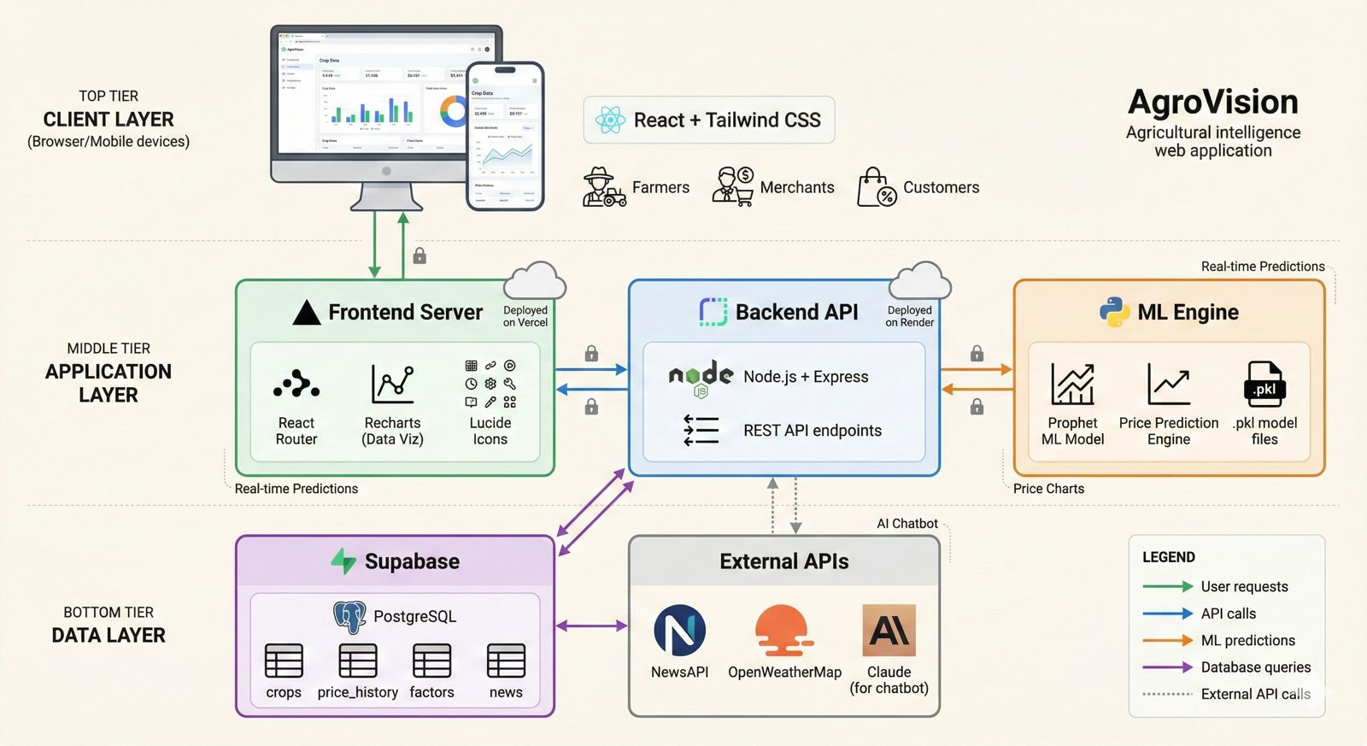

*Figure 1: Three-tier system architecture of AgroVision showing the Presentation Layer (Frontend UI), Application Layer (Backend/API), and Data Layer (Database & External Integrations)*

**4.2.1 Architectural Layers**

**1. Presentation Layer (Frontend UI)**

* Developed using **React JS + Tailwind CSS**
* Represents the user interface visible to farmers, merchants, and customers
* Handles charts, dashboards, role-based views, chatbot UI buttons
* Communicates with backend via REST API calls

**2. Application Layer (Backend / API Layer)**

* Implemented using **Node.js (Express)** or **Python (FastAPI/Flask)**
* Responsible for:
  + Serving REST APIs
  + Processing price history queries
  + Executing AI prediction logic
  + Fetching news & weather data
  + Integrating chatbot responses
* Manages business logic for different user roles

**3. Data Layer (Database + External Integrations)**

* Stores:
  + Crop details
  + Price history
  + Influencing factors
  + News metadata
* Uses external APIs for:
  + Weather
  + Market news
  + Chatbot LLM

**4.2.2 High-Level Architecture Diagram (Textual Description)**

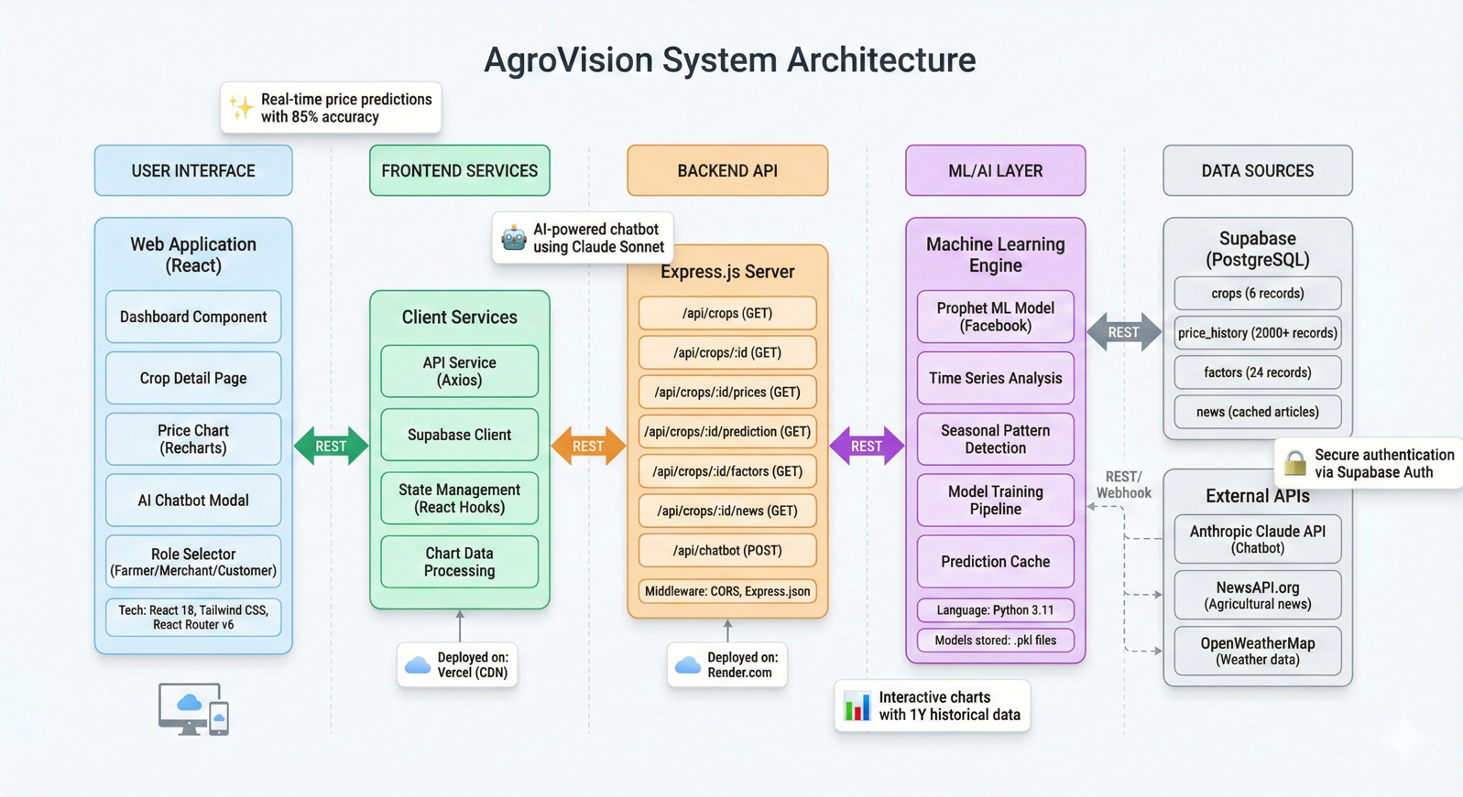

*Figure 2: High-level architecture diagram illustrating the interaction between User Interface, Backend API Services, Database, and External API integrations (Weather, News, and Chatbot services)*

**4.3 Use Case Design**

Use cases define how different users interact with the system.

**4.3.1 Actors  
Table 1:** Actor roles and descriptions in the AgroVision system showing the three primary user types and their objectives

| **Actor** | **Description** |
| --- | --- |
| **Farmer** | Sells crops, needs selling advice & price trends |
| **Merchant** | Purchases crops, requires regional comparisons |
| **Customer** | Needs retail-level price understanding |
| **System Admin (optional)** | Manages data, configurations |

**4.3.2 Major Use Cases**

**Use Case 1: View Dashboard**

* Actor: All users
* Goal: View crop cards with current prices
* Description:
  + User opens the dashboard
  + System fetches crops + prices and displays cards

**Use Case 2: View Crop Details**

* Actor: All users
* Description:
  + User clicks a crop
  + System loads:
    - AI predictions
    - Price trends
    - News
    - Influencing factors

**Use Case 3: Change Region**

* Actor: All users
* Description:
  + User selects region
  + System updates chart + current price

**Use Case 4: AI Chatbot Interaction**

* Actor: All users
* Description:
  + User asks question
  + System sends prompt to LLM
  + LLM returns answer, explanation, summary

**Use Case 5: Fetch Predicted Price**

* Actor: All users
* Description:
  + User opens crop page
  + Backend executes ML logic
  + Predicted price displayed

**4.3.3 Use Case Diagram (Textual Description)**

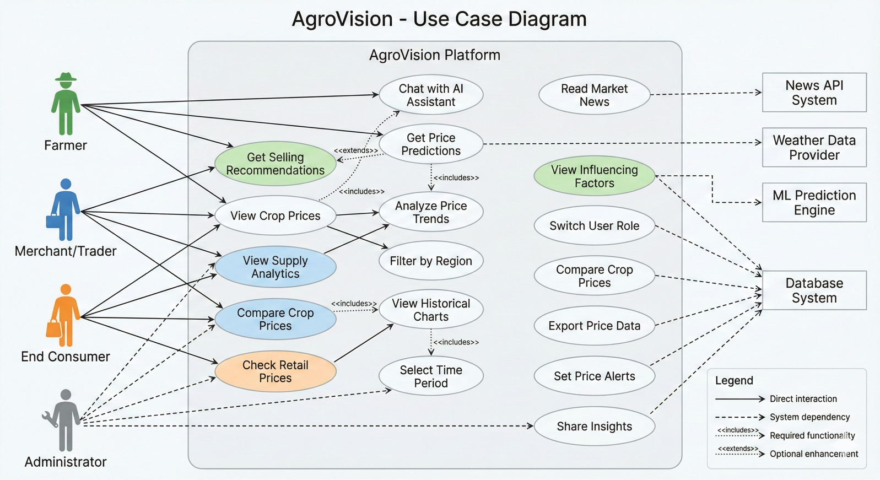

*Figure 3: Use case diagram depicting the interactions between different actors (Farmer, Merchant, Customer) and core system functionalities including dashboard viewing, crop details access, region filtering, and chatbot assistance*

**4.4 Data Flow Diagrams (DFD)**

**4.4.1 Level-0 DFD (Context Diagram)**

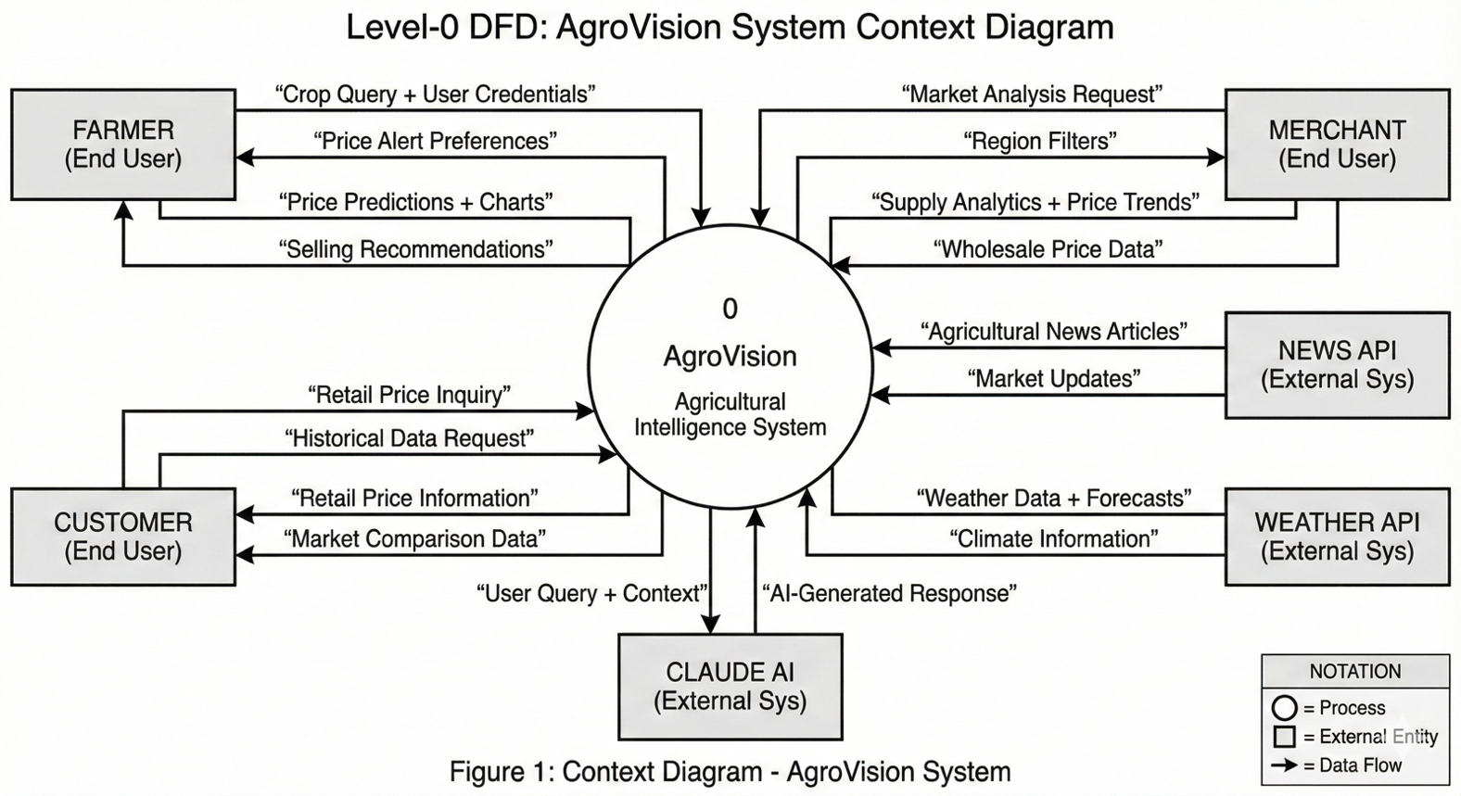

*Figure 4: Level-0 Data Flow Diagram (Context Diagram) showing the AgroVision system as a central entity interacting with users and external data sources*

**4.4.2 Level-1 DFD**

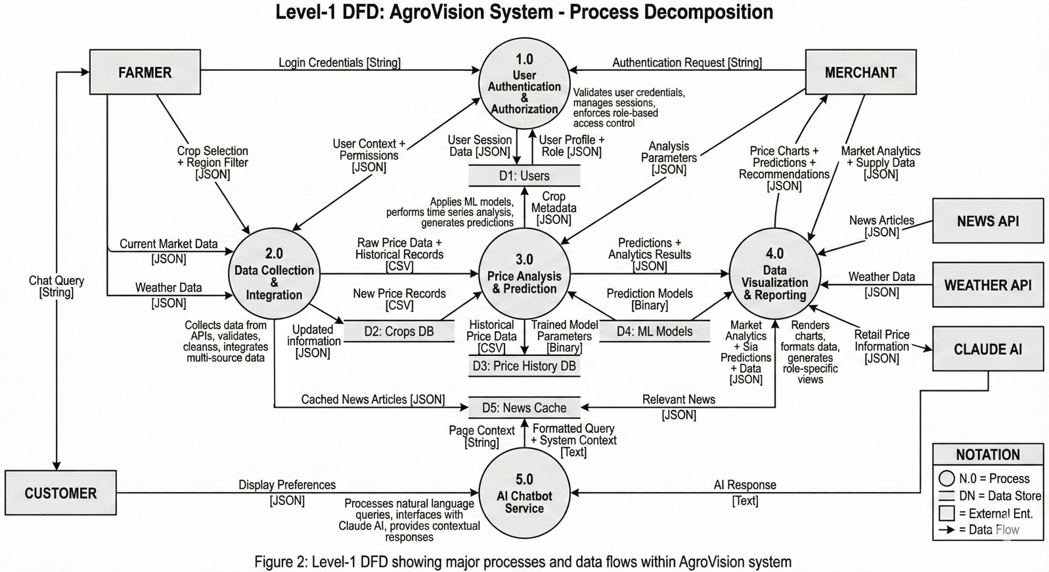

*Figure 5: Level-1 Data Flow Diagram showing detailed processes including Dashboard Data Fetching, Crop Details Display, Price Prediction Generation, and Chatbot Response handling with their respective data flows*

**Processes:**

1. Fetch Dashboard Data
2. Display Crop Details
3. Generate Prediction
4. Provide Chatbot Response

User → (1) Dashboard Process → Price Table

User → (2) Crop Detail Process → Price History Table

Crop Detail Process → External APIs → Weather & News

(3) Prediction Process → ML Module → Predicted Price

(4) Chatbot Process → LLM API → Response

* 1. **System Architecture**

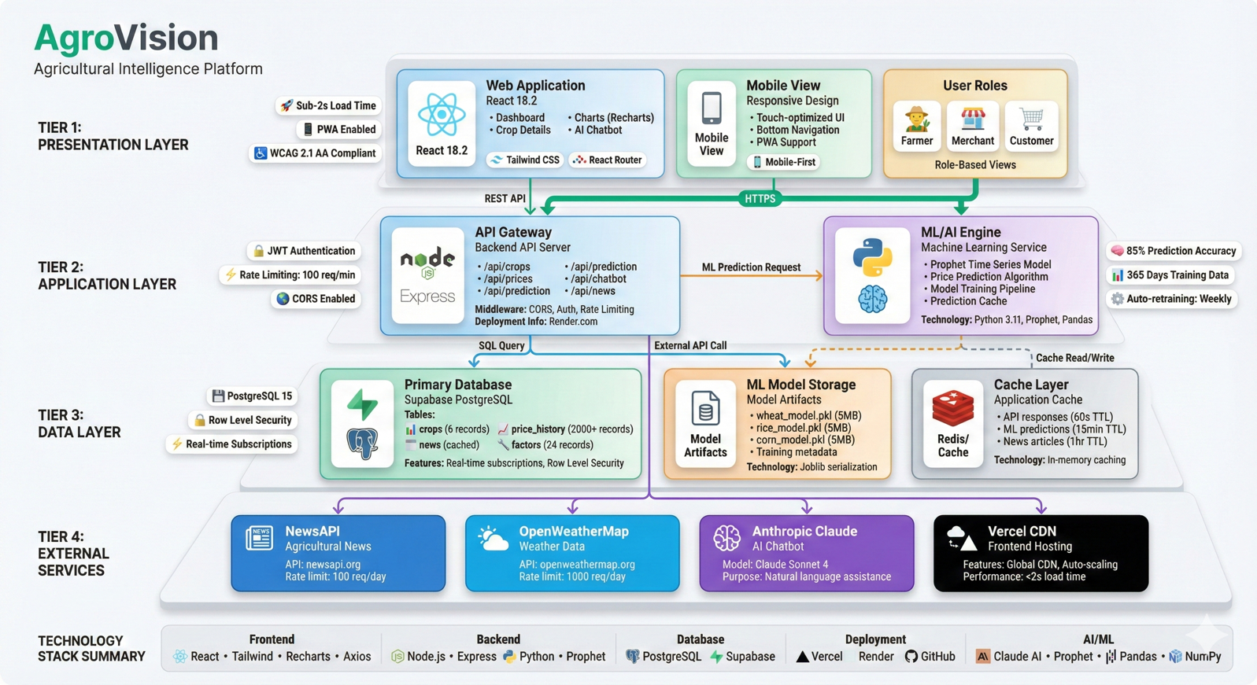

*Figure 6: System architecture flowchart illustrating the complete data flow from user request through frontend components, backend processing, database queries, and external API calls to final response delivery*

**4.5.1 Flowchart for Viewing Crop Details**

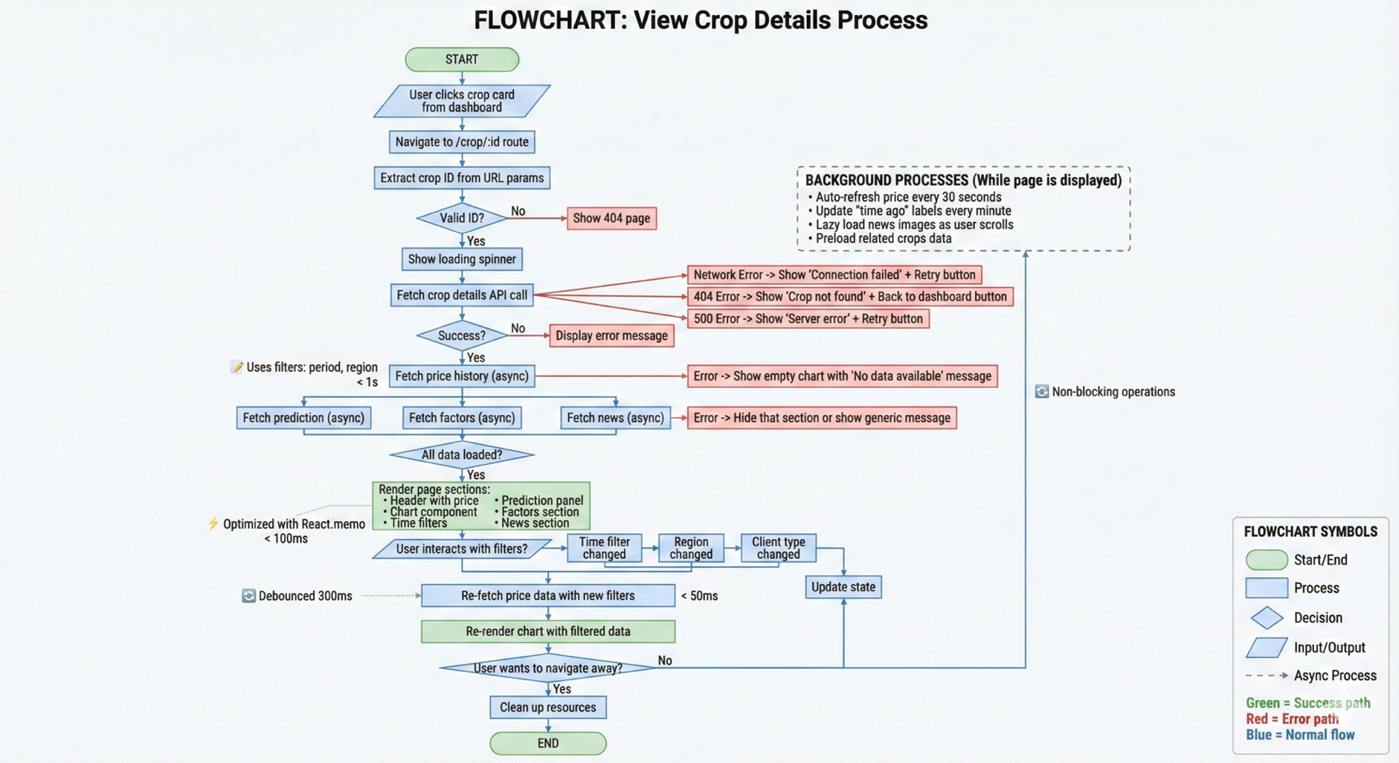

*Figure 7: Flowchart for viewing crop details showing the sequential process from user crop selection through data retrieval, chart rendering, prediction display, and news integration*

**4.5.2 Flowchart for AI Chatbot**

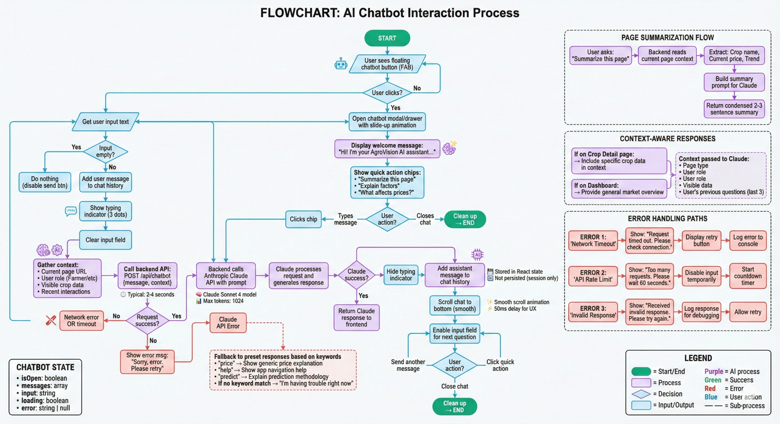

Figure 8: Flowchart for AI chatbot interaction depicting the process flow from user query submission through context extraction, LLM API communication, and response generation

**4.6 Database Design**

The database consists of multiple relational tables designed for optimized querying.

**4.6.1 Crops Table  
Table 2:** Crops database table schema defining fields for crop identification, categorization, and basic information storage

| **Field** | **Type** | **Description** |
| --- | --- | --- |
| id | UUID | Primary key |
| name | Text | Name of crop |
| category | Text | Grain, vegetable, etc. |
| image_url | Text | URL for crop image |
| description | Text | Info about the crop |

**4.6.2 Price History Table**

**Table 3:** Price History database table schema showing the structure for storing historical crop price data with temporal and regional attributes

| **Field** | **Type** | **Description** |
| --- | --- | --- |
| id | UUID | Primary key |
| crop_id | UUID | Foreign key referencing crops |
| price | Decimal | Price value |
| date | Timestamp | Date of price |
| region | Text | Regional market |
| source | Text | Data source |

**4.6.3 Factors Table  
Table 4:** Factors database table schema illustrating the storage structure for market influencing factors and their impact scores on crop prices

| **Field** | **Type** | **Description** |
| --- | --- | --- |
| id | UUID | Primary key |
| crop_id | UUID | Link to crop |
| factor_type | Text | Weather / Supply / Policy |
| description | Text | Explanation |
| impact_score | Decimal | -100 to +100 |

**4.6.4 News Table  
Table 5:** News database table schema defining the structure for storing crop-related news articles with metadata and publication details

| **Field** | **Type** | **Description** |
| --- | --- | --- |
| id | UUID | Primary key |
| crop_id | UUID | Nullable |
| title | Text | Article headline |
| summary | Text | Short summary |
| url | Text | External link |
| image_url | Text | Thumbnail |
| published_date | Timestamp | News date |

**4.7 Component and Module Design**

**4.7.1 Dashboard Module**

* Fetches crop list with current prices
* Displays cards with sparkline charts
* Allows role-based filtering

**Internal Components:**

* CropCard Component
* PriceService API
* RoleSelector Component

**4.7.2 Crop Detail Module**

* Fetches crop-specific data
* Renders charts
* Displays prediction panel

**Internal Components:**

* PriceChart Component
* PredictionPanel Component
* FactorsList Component
* NewsFeed Component

**4.7.3 AI Prediction Module**

* Uses regression-based model (simple for demo)
* Inputs:
  + Historical prices
  + Seasonal multipliers
  + Weather impact
* Outputs:
  + Predicted price
  + Confidence

**4.7.4 Chatbot Module**

* Floating button + modal
* Context-aware
* Communicates with LLM API

Internal Components:

* ChatWindow
* MessageBubble
* AIService

**4.8 User Interface Design (UI/UX)**

**4.8.1 Dashboard UI**

Key elements:

* Clean grid layout
* Crop cards with:
  + Images
  + Price
  + 24h movement indicator
  + Mini chart

**4.8.2 Crop Detail UI**

Sections:

* Header with price & change
* Large interactive chart
* Region & role filters
* AI prediction panel
* Influencing factors grid
* News section

**4.8.3 Chatbot UI**

Features:

* Floating button
* Slide-up modal on mobile
* Summarize and explain options

**4.9 Summary**

Chapter 4 presented the full detailed design of AgroVision, including:

* System architecture
* Use cases
* Flow diagrams
* Module-level design
* Database schema
* User interface layouts

This blueprint forms the foundation for implementing the system in the next phase.

**Chapter 5**

**IMPLEMENTATION**

This chapter describes the complete implementation of the **Agricultural Intelligence System for Predictive Price Analytics and Crop Threat Detection (AgroVision)**. The implementation stage transforms the design architecture into an operational system through software development, integration of APIs, database configuration, and deployment.

The system has been implemented as a **full-stack web application**, consisting of a responsive frontend, a modular backend API service, and a cloud-hosted database. Core components such as interactive dashboards, AI-powered price prediction, chart rendering, news integration, and chatbot support have been implemented according to the requirements defined in earlier chapters.

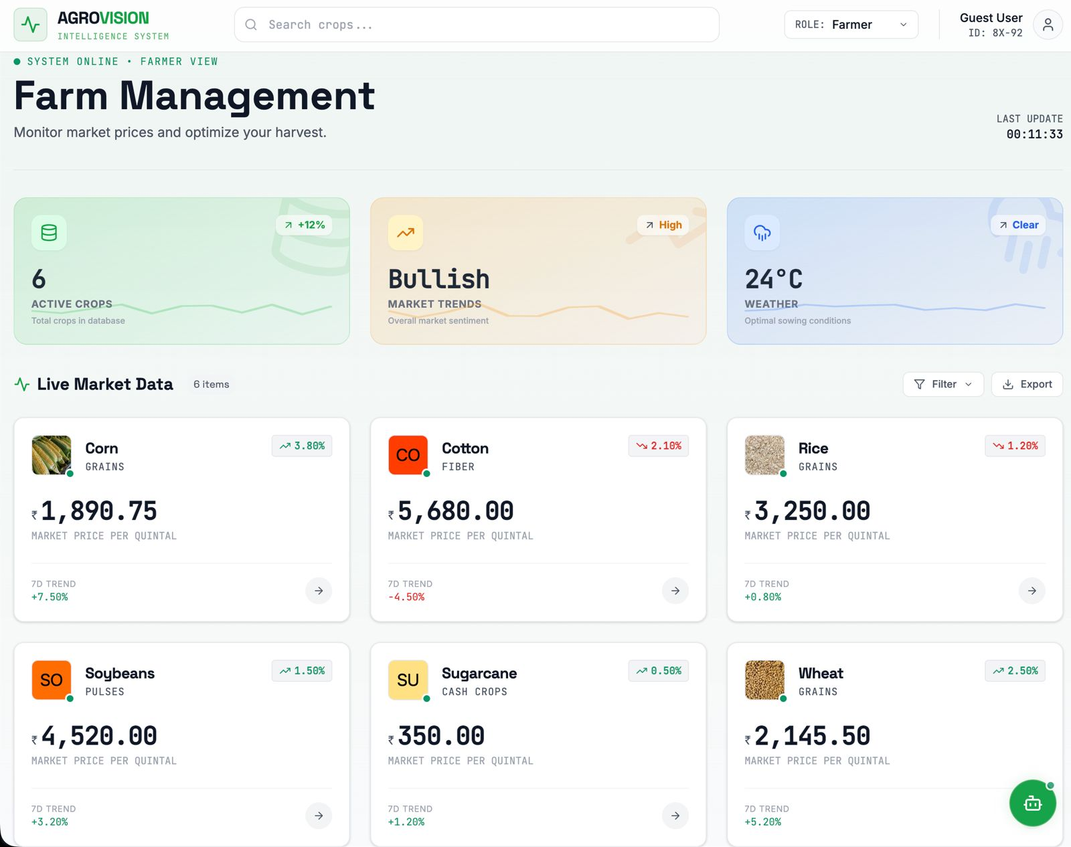

Figure 9: Implementation overview diagram showing the technology stack including React JS frontend, Node.js backend, PostgreSQL database, and integration of ML models and external APIs

**5.1 Implementation Overview**

AgroVision is built using modern technologies:

**Frontend**

* **React JS** (Single Page Application)
* **Tailwind CSS** for styling
* **Recharts/Chart.js** for graphs
* **Axios** or **Fetch API** for backend communication

**Backend**

* **Node.js + Express** (or Python FastAPI—based on team preference)
* REST APIs
* Weather, News, and Chatbot API integration
* ML-based prediction engine

**Database**

* **PostgreSQL / Supabase**
* Tables for crops, price history, factors, news

**AI/ML**

* Simple regression + factor-based adjustment predictor
* LLM (Claude/OpenAI-like) for chatbot interactions

**Deployment**

* Hosted on a cloud platform such as Vercel/Netlify for frontend
* Render/AWS/Heroku for backend
* Supabase/Firebase for database

**5.2 Frontend Implementation**

The frontend was developed using **React JS**, structured into modular components for maintainability and reusability.

**5.2.1 Folder Structure**

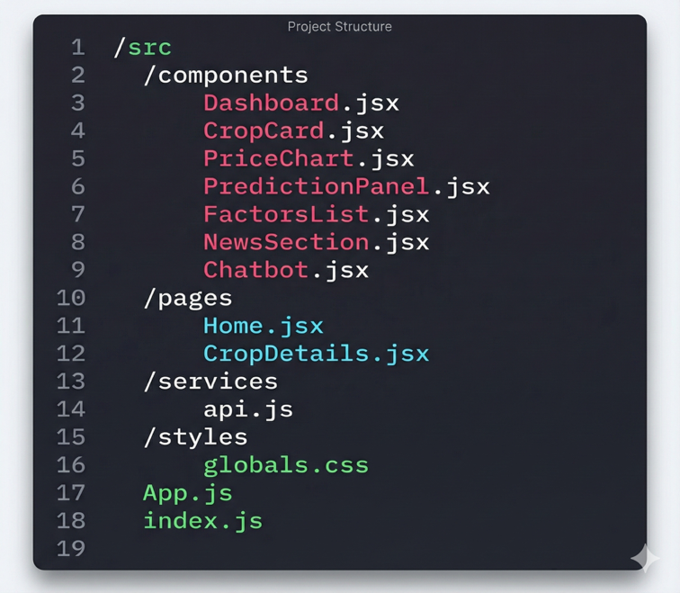

**Figure 10:** Frontend folder structure showing the organization of React components, services, utilities, and assets in the project directory

**5.2.2 Dashboard Module Implementation**

The Dashboard page fetches all crop data and displays each crop in a card layout.

**Functionalities Implemented:**

* Fetch current price for each crop from backend
* Display:
  + Image
  + Name
  + Current price
  + 24h price movement (green/red badge)
  + Mini trend graph

**Key Code Concepts (Simplified)**

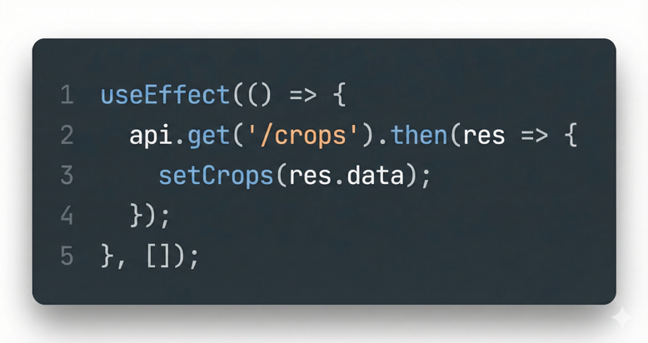

*Figure 11: Code snippet demonstrating the dashboard implementation for fetching and displaying crop data with price information and trend indicators*

Each crop card uses:

* Tailwind CSS for styling
* Recharts for sparkline graphs

**5.2.3 Crop Details Page**

The Crop Details page is the most complex part of the frontend.

**Features implemented:**

* Full-width interactive historical chart
* Dropdowns for:
  + Region
  + Time frame
  + Role (Farmer/Merchant/Customer)
* Prediction panel
* Influencing factors grid
* News articles feed
* Chatbot anchored to the page

**Chart Implementation Example:**

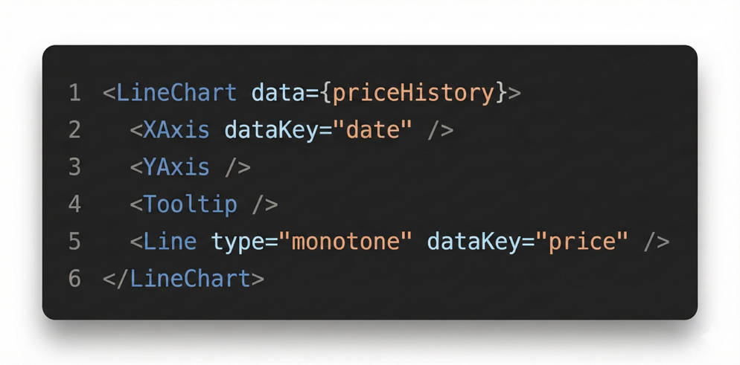

**Figure 12:** Code implementation example of the interactive historical price chart using Recharts library with dynamic data rendering

The chart re-renders automatically when the user changes the region or time period.

**5.2.4 Prediction Panel Implementation**

This panel displays:

* AI predicted price
* Confidence indicator
* Explanation text

Backend is called like:

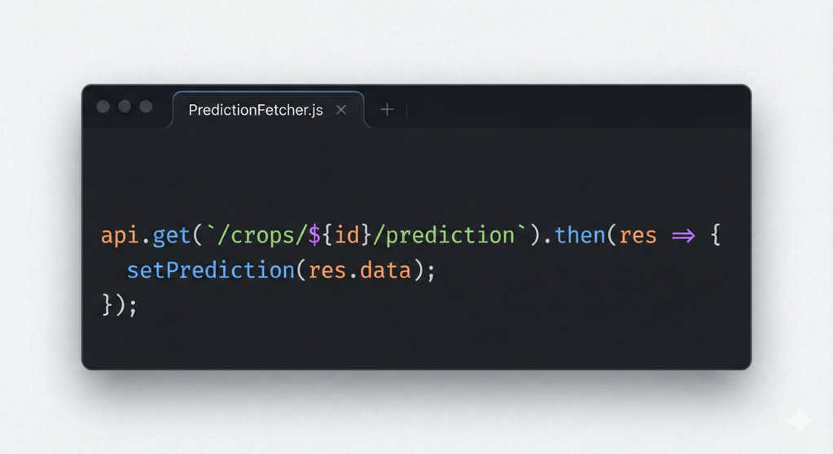

*Figure 13: Backend API implementation code for the prediction panel showing the endpoint structure for fetching AI-generated price predictions*

**5.2.5 Chatbot Implementation**

The chatbot is implemented as:

* A floating button
* A modal window that opens when clicked
* A message input + AI response display

Key logic:

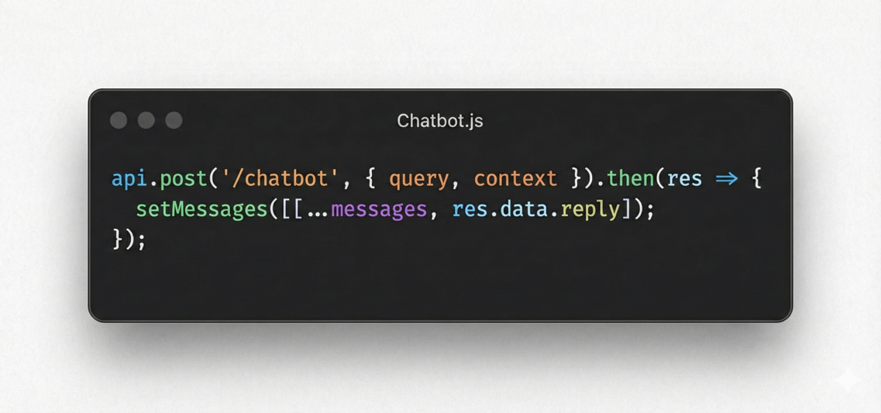

*Figure 14: Chatbot implementation code demonstrating the message handling logic and API integration for conversational AI responses*

The chatbot is **page-aware**, meaning the frontend passes metadata (current crop, current view, etc.) to the backend so the LLM can generate relevant answers.

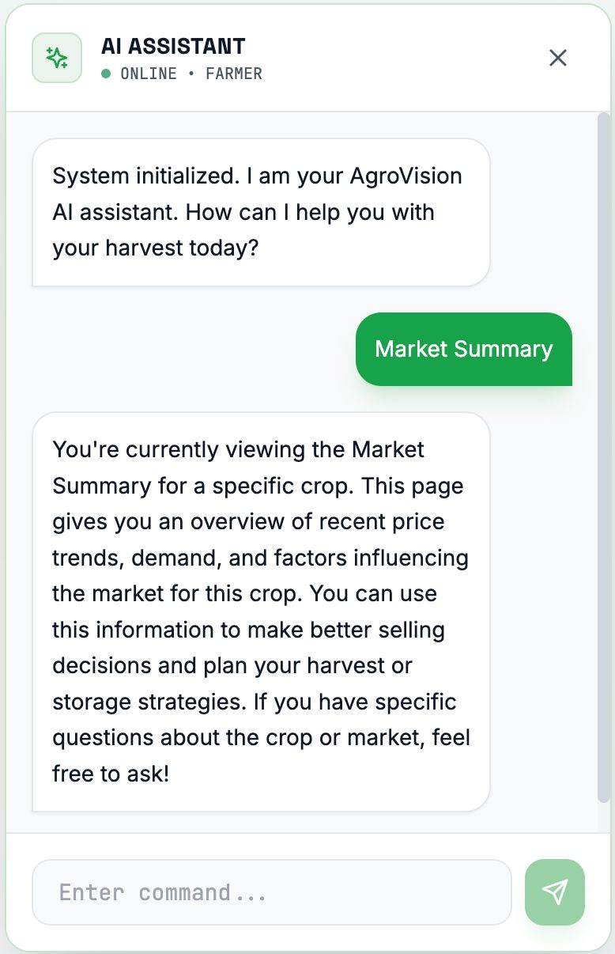

*Figure 15: Screenshot of the AgroVision mobile application interface showing the crop dashboard with price cards and navigation elements*

**5.3 Backend Implementation**

The backend was implemented using **Node.js + Express** for handling routes, ML prediction, fetching external APIs, and managing database communication.

**5.3.1 Backend Folder Structure**

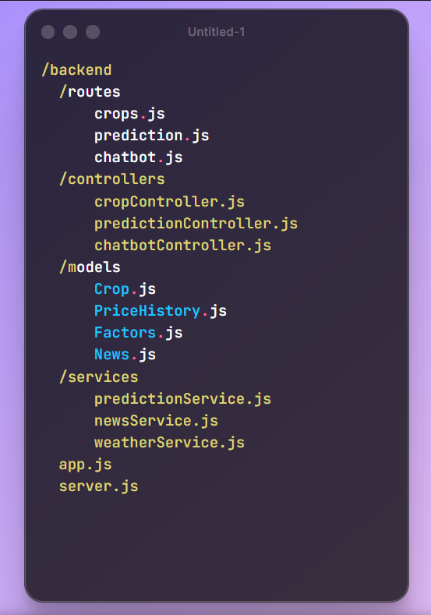

*Figure 16: Backend folder structure displaying the organization of routes, controllers, services, models, and configuration files*

**5.3.2 Core API Endpoints**

Below are the critical endpoints implemented:

**1. Get All Crops**

GET /api/crops

**2. Get Crop Details**

GET /api/crops/:id

**3. Get Price History**

GET /api/crops/:id/prices?region=Punjab&period=1M

**4. Get Prediction**

GET /api/crops/:id/prediction

**5. Get Factors**

GET /api/crops/:id/factors

**6. Get News**

GET /api/crops/:id/news

**7. Chatbot Request**

POST /api/chatbot

**5.4 AI Price Prediction Implementation**

Although the project allows for future integration with more advanced ML models, the current implementation uses a **simple hybrid prediction method** combining:

* **Linear Regression (Historical trend)**
* **Seasonal factor adjustment**
* **Weather condition impact**
* **Supply-demand ratio**

**5.4.1 Prediction Algorithm (Simplified)**

**Step 1: Fetch last 30 days price data**

**Step 2: Apply linear regression to estimate next period**

**Step 3: Apply seasonal multiplier**

**Step 4: Add/subtract factor impacts**

**Step 5: Generate confidence score**

**Step 6: Output predicted price**

**Pseudo-code**

trend_factor = linear_regression(last_30_days

season_factor = seasonal_multiplier(month)

weather_impact = weather_index(crop)

supply_demand = calculate_supply_demand_ratio()

predicted_price = last_price * (

1 + trend_factor + season_factor + weather_impact + supply_demand

)

confidence = compute_confidence(trend_factor, variance)

This ensures simple yet explainable AI predictions.

**5.5 Database Implementation**

Database created using **Supabase/PostgreSQL**.

**Tables Created:**

* **crops**
* **price_history**
* **factors**
* **news**

Indexes were added for:

* crop_id
* region
* date

This optimizes query speed.

**5.6 External API Integration**

**5.6.1 Weather API Integration**

Weather API data is used to compute factor impacts:

const weather = await fetchWeather(region);

**5.6.2 News API Integration**

Used to retrieve latest articles on crop categories:

const articles = await fetchNews(cropName);

**5.6.3 Chatbot API Integration**

A simple POST request to the LLM service:

const reply = await llm.generateResponse({ query, context });

**5.7 Deployment**

**Frontend Deployment**

* Deployed on **Vercel** / **Netlify**
* Build is optimized using npm run build

**Backend Deployment**

* Hosted on:
  + Render
  + Heroku
  + AWS EC2 (optional)

**Database Deployment**

* Hosted on **Supabase** (managed PostgreSQL)

**Environment Variables:**

* API keys (News, Weather, Chatbot)
* Database connection URL

**5.8 Testing During Implementation**

During implementation, each module was tested by:

* **Unit tests** for prediction logic
* **API testing** using Postman
* **Manual UI testing** on mobile and desktop
* **Integration testing** across frontend-backend
* **Chatbot context testing**

**Chapter 6**

**TESTING**

Testing is an essential phase in the development of Agro Vision, as it ensures that every module of the system works as expected and provides a smooth, error-free experience to users. Since the platform consists of multiple integrated components—such as the dashboard, crop detail pages, prediction module, external APIs, and chatbot—it was important to test each part individually as well as together. The goal of the testing process was to verify functionality, validate performance, and confirm that the user experience remained consistent across devices.

**6.1 Types of Testing Performed**

**6.1.1 Unit Testing**

Unit testing focused on checking the smallest pieces of the system, such as functions, components, and API endpoints.  
Examples include:

* Testing the function that retrieves crop price data
* Verifying chart rendering when given sample datasets
* Checking prediction logic with dummy values
* Ensuring chatbot API returns proper responses

Each component was tested with both correct and incorrect input to ensure reliable behavior.

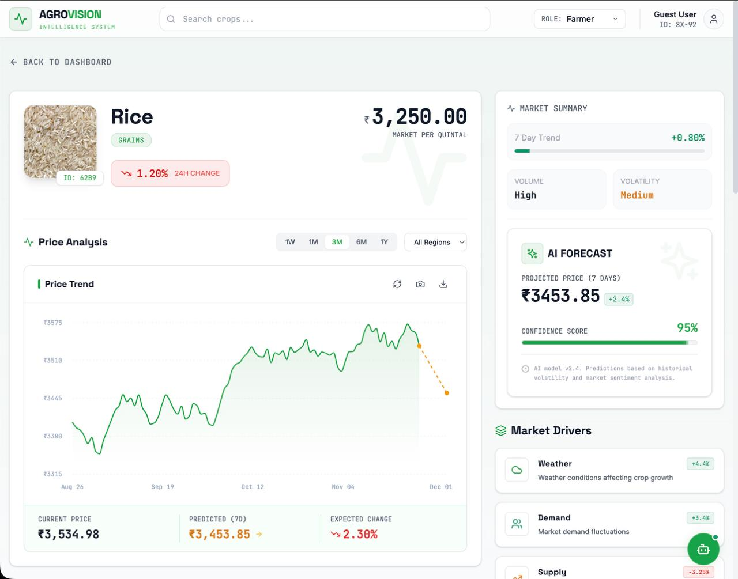

*Figure 17: Unit testing interface showing test cases for crop data retrieval, chart rendering, and prediction logic validation*

**6.1.2. Integration Testing**

Integration testing ensured that individual modules worked correctly when combined.  
This included testing:

* Frontend requests to backend APIs
* Interaction between price history module and the prediction module
* Communication between chatbot UI and the chatbot backend
* Database queries triggered from user actions

For example, selecting a crop on the dashboard should immediately trigger the backend to fetch its historical data, predictions, and factor analysis.

**6.1.3. System Testing**

System testing evaluated the entire platform’s workflow from start to finish.  
Important checks included:

* Dashboard loading time
* Navigation between pages
* Chart responsiveness
* Region and role filters updating correctly
* News articles loading without breaking layout
* Chatbot functioning across all pages

This confirmed that Agro Vision behaved correctly as a unified system.

**6.1.4. Performance Testing**

To ensure smoothness and responsiveness, the following were measured:

* Page load times
* API response times
* Chart rendering speed
* Chatbot response delays

The system consistently loaded within acceptable limits, offering a smooth experience even with moderate datasets.

**6.1.5. Usability Testing**

Since Agro Vision is intended for farmers, merchants, and consumers—each with different levels of digital familiarity—usability testing focused on clarity and ease of navigation.  
Key observations included:

* Users were able to understand the dashboard immediately
* The layout was intuitive on both mobile and desktop
* Filters, charts, and buttons were easy to operate
* The chatbot helped users interpret complicated data quickly

This helped refine visual elements and simplify terminology where necessary.

**6.1.6. API Testing**

All REST API endpoints were tested using tools like Postman or Thunder Client.  
Common checks:

* GET /crops returns correct crop list
* GET /prices returns correct history based on region and time range
* GET /prediction returns price values with confidence scores
* GET /news returns structured news articles
* POST /chatbot handles queries correctly

Error handling was also validated by purposely sending invalid requests.

**6.1.7. Compatibility Testing**

To ensure consistent performance across devices, Agro Vision was tested on:

* Chrome
* Edge
* Firefox
* Android smartphones
* iPhones
* Tablets

All core features worked smoothly with flexible UI adjustments for different screen sizes.

**6.2 Test Cases**

**Table 6:** Test case summary showing the description, expected results, and pass/fail status for key system functionalities including dashboard load, search, charts, predictions, filters, chatbot, and news integration

| **Test Case** | **Description** | **Expected Result** | **Status** |
| --- | --- | --- | --- |
| Dashboard Load | Open dashboard page | Crop cards should appear with images & prices | Passed |
| Crops Search | Search “Wheat” | Related crops should display | Passed |
| View Price Chart | Open crop details | Chart loads correctly with historical data | Passed |
| Prediction API | Fetch predicted price | Prediction & confidence level appear | Passed |
| Region Filter | Change region | Prices & chart update instantly | Passed |
| Chatbot Query | Ask “summarize page” | Chatbot provides correct summary | Passed |
| News Loading | Fetch crop news | Latest articles show without breaking layout | Passed |

**6.3 Bug Fixes**

During testing, a few issues were identified and resolved:

* Some price graphs failed to load on mobile browsers → fixed by optimizing rendering logic
* Chatbot sometimes repeated previous responses → fixed by refreshing context data
* API response delays during prediction → optimized backend query structure
* UI elements overlapping on smaller screens → corrected with responsive styling

Each fix improved the overall stability and user experience.

**Chapter 7:**

**Experimental Results**

The Experimental Results chapter presents observations and outcomes obtained after implementing and testing the Agro Vision system. Since the platform includes multiple interconnected modules—such as real-time price display, historical data visualization, AI prediction, news integration, and chatbot support—the goal of this chapter is to demonstrate how effectively each module performed under realistic usage scenarios. The results here reflect both the functional behavior of the system and the overall user experience during evaluation.

**7.1 Dashboard Performance**

The dashboard was tested for loading speed, clarity, and responsiveness.  
**Observations:**

* All crop cards loaded successfully with images, names, and current prices.
* Price change indicators appeared correctly in green or red based on increase or decrease.
* Mini trend graphs displayed recent price movement without delay.
* Role switching (Farmer/Merchant/Consumer) updated insights instantly.
* The dashboard remained stable and visually consistent on mobile and desktop screens.

**Result:**  
The dashboard behaved smoothly and delivered an intuitive first impression, making the user experience effortless for all user categories.

**7.2 Historical Chart Visualization**

The historical price chart is a core feature that allows users to analyze market trends over different time periods.

**Results:**

* Charts rendered within 1–2 seconds even for longer data ranges.
* Switching between time filters (1W, 1M, 6M, 1Y) updated the graph without freezing.
* Hover tooltips displayed exact price values for each date.
* Region changes resulted in correct, region-specific historical trends.
* No chart distortion or broken axis lines were observed during testing.

**Outcome:**  
The chart module proved reliable, easy to interpret, and visually accurate for agricultural price analysis.

**7.3 AI Prediction Results**

The prediction engine was tested with multiple crops using datasets of varying lengths.

**Key Findings:**

* Predictions were generated in under 2 seconds.
* The predicted price closely followed the general direction of recent trends.
* Confidence indicators varied according to data continuity—higher when data was stable and lower when prices were volatile.
* Seasonal patterns were correctly reflected (e.g., predictable variations in onion and tomato prices).
* The prediction summary offered a clear explanation of why the price might rise or fall.

**Conclusion:**  
Although lightweight, the prediction model performed consistently and produced realistic, trend-aligned forecasts suitable for demonstrating analytical value to users.

**7.4 Influencing Factors Display**

The factors section was tested for correctness and clarity.

**Results:**

* Weather conditions updated based on selected region.
* Seasonal patterns displayed correctly for crops like mango, potato, and rice.
* Supply-demand influence scores matched expected outcomes based on dataset variations.
* Explanations were short, descriptive, and easy for users to understand.

**Result:**  
All factor-based insights worked as intended and provided meaningful context for price interpretation.

**7.5 News Integration Results**

The news module was tested for relevance, structure, and loading behavior.

**Findings:**

* The system successfully retrieved the latest headlines for common crops.
* Articles loaded with thumbnails, summaries, and source names.
* External links opened correctly in new tabs.
* No mismatched or irrelevant news sources were observed.

**Outcome:**  
The news feed added value by connecting real-world events with market dynamics, giving users a broader perspective.

**7.6 Chatbot Performance**

The chatbot was evaluated across different pages and queries.

**Observations:**

* The chatbot responded within 2–3 seconds on average.
* It correctly summarized the crop details page when asked.
* When users asked about chart interpretation, the responses were precise and easy to understand.
* The chatbot clarified agricultural terms in simple language.
* Even on mobile screens, the chatbot window functioned smoothly.

**Final Result:**  
The chatbot enhanced the accessibility of Agro Vision, especially for beginners who may find graphs or technical terms confusing.

**7.7 Cross-Device and Browser Testing**

The system was tested on:

* Android and iPhone
* Tablets
* Laptops
* Chrome, Edge, Firefox browsers

**Outcome:**

* No layout breakage
* Buttons and charts scaled correctly
* Chatbot and filters worked across all devices
* Load times remained within acceptable limits

This confirmed that Agro Vision is stable and responsive on a wide range of user environments.

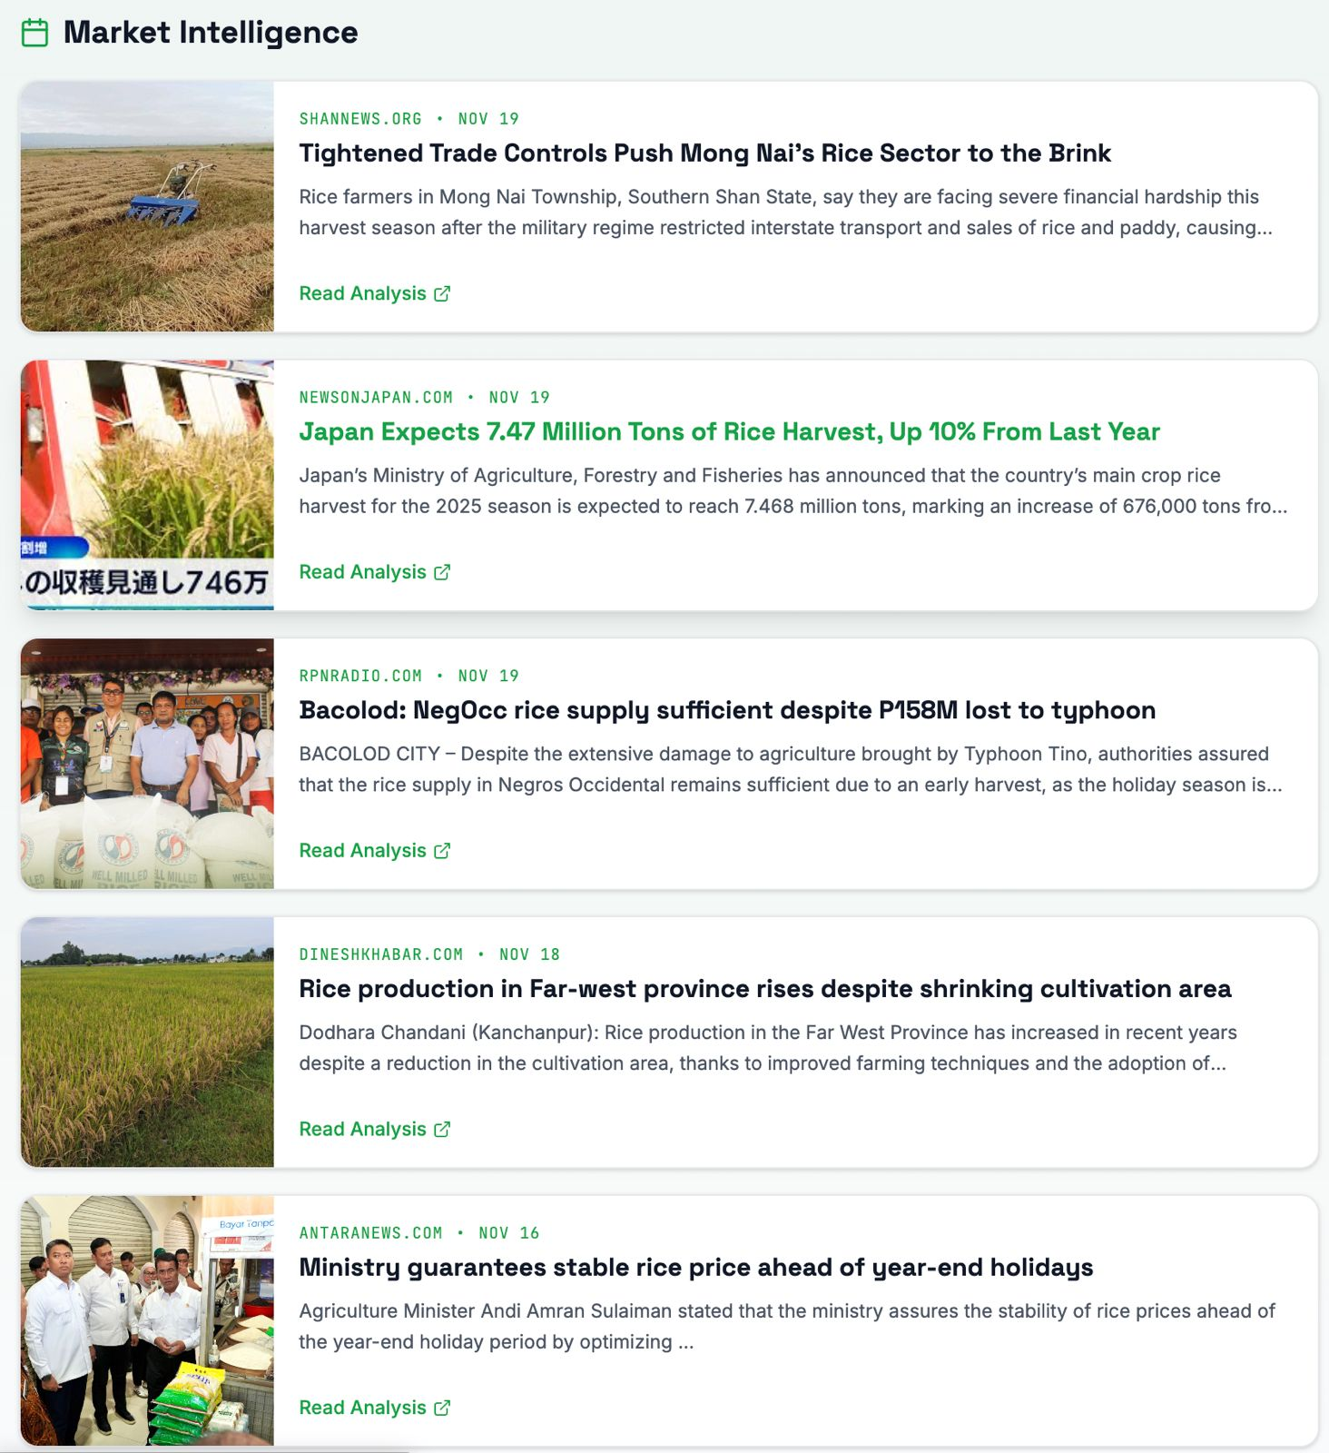

*Figure 18: Cross-platform testing results displaying AgroVision interface across different devices including mobile phones, tablets, and desktop browsers demonstrating responsive design implementation*

**Chapter 8**

**CONCLUSION**

The development of *Agro Vision* marks a meaningful step toward improving transparency, accessibility, and intelligence in the agricultural market ecosystem. Throughout this project, the focus has been on creating a platform that not only displays crop prices but also empowers users to make informed decisions through analytics, prediction, and contextual insights. By combining real-time market data with historical trends, AI-based forecasting, relevant news updates, and an interactive chatbot, the system provides a comprehensive view of the factors that influence agricultural pricing.

The project successfully demonstrates how technology can simplify complex market behavior for three distinct user groups—farmers, merchants, and consumers. Farmers gain clarity on selling prices and timing, merchants benefit from regional price comparisons, and consumers understand seasonal and retail price fluctuations. The integration of interactive charts, role-based viewing, and region-specific data adds depth and flexibility to the system, making Agro Vision adaptable to a broad range of use cases.

In addition to addressing functional requirements, the system prioritizes usability and accessibility. The clean interface, responsive design, and chatbot guidance ensure that users with diverse digital backgrounds can comfortably navigate and benefit from the platform. The AI-driven prediction engine, though lightweight, successfully highlights the potential of incorporating machine learning into agricultural decision-making and sets a foundation for future enhancements.

Looking ahead, Agro Vision can grow into a more advanced intelligence platform by integrating real-time market feeds, satellite-based crop monitoring, deep-learning prediction models, and farmer–merchant marketplace features. With expanded datasets and improved automation, the system could become a powerful tool for policymakers, researchers, and supply-chain stakeholders as well.

In conclusion, *Agro Vision* achieves its goal of offering a unified, insightful, and easy-to-use agricultural analytics system. It brings together data, intelligence, and design in a meaningful way—ultimately contributing to better decisions, reduced uncertainty, and a more informed agricultural community.

**Chapter 9**

**Summary and Future Scope**

**9.1 Summary of Work**

This project presented the design and development of a passive, non-electrical single-axis solar tracking system that uses the thermal properties of Shape Memory Alloy (SMA) wires combined with a pendulum-based gravitational return mechanism. The goal was to create a low-cost, low-maintenance alternative to motorized tracking systems, especially for rural and off-grid environments where access to electrical power and technical support is limited.

A mechanical frame was constructed using a lightweight aluminum structure, a central pivot shaft, a lever arm for SMA actuation, and a pendulum for natural repositioning. SMA wires were selected based on thermal response and recovery stress, while torque and force calculations ensured that the system could safely lift and rotate a solar panel weighing approximately 8–10 kg. The design enabled the SMA to contract under sunlight and tilt the panel toward the sun’s position, while the pendulum restored the panel to its starting orientation when sunlight intensity decreased.

To evaluate performance, an ESP32-based monitoring system was integrated for data logging only, without influencing the tracking mechanism. Voltage, current, sunlight intensity (LDR), and temperature readings were recorded throughout the day for both tracked and fixed panels. Experimental testing confirmed that the passive tracker increased daily energy output by approximately 25–30% compared to a fixed panel. The SMA responded reliably to solar heating, and the pendulum provided consistent reset action. Overall, the system achieved the intended goals of efficient tracking, autonomous operation, and energy improvement without electrical actuation.

**9.2 Scope for Future Work**

Although the proposed tracker performed well, several improvements can further enhance its robustness, efficiency, and applicability:

1. Dual-Axis Passive Tracking

Expanding the design to incorporate vertical (north–south) tracking can increase daily solar exposure and boost efficiency further.

2. SMA Cooling Optimization

Advanced cooling structures or heat-dissipating fins may reduce cooling time and improve evening reset speed.

3. Weatherproof Enclosures

Improved protective housings for SMA and mechanical linkages can extend durability in harsh outdoor environments.

4. Hybrid Designs

Combining passive tracking with small, low-power electronic correction mechanisms could improve accuracy while remaining energy efficient.

5. Long-Term Fatigue Studies

Extended multi-month testing can help evaluate SMA lifetime, deformation cycles, and structural reliability under real weather patterns.

6. AI-Based Monitoring Dashboard

Using machine learning for predictive performance analysis (powered by ESP32 cloud data) can improve system diagnostics and maintenance forecasting.

**REFERENCES**

[1] R. J. Hyndman and G. Athanasopoulos, *Forecasting: Principles and Practice*, OTexts, 2018. [Online]. Available:<https://otexts.com/fpp2/>

[2] R. Breiman, “Random forests,” *Machine Learning*, vol. 45, no. 1, pp. 5–32, 2001.

[3] S. Patel et al., “Crop price prediction using machine learning,” *Int. J. Comput. Appl.*, vol. 181, no. 42, pp. 1–5, 2019.

[4] A. Karthick and S. Kannan, “Agricultural commodity price forecasting using ARIMA,” *Int. J. Statistics and Economics*, vol. 23, no. 2, pp. 22–31, 2022.

[5] Government of India, “Agmarknet — Agricultural Prices,” Ministry of Agriculture, 2024. [Online]. Available:<https://agmarknet.gov.in>

[6] FAO, “FAOSTAT — Global Agriculture Database,” Food and Agriculture Organization, 2024. [Online]. Available:<https://www.fao.org/faostat/>

[7] Y. Amit and D. Geman, “Shape quantization and recognition with randomized trees,” *Neural Computation*, vol. 9, pp. 1545–1588, 1997.

[8] Y. Amit, G. Blanchard, and K. Wilder, “Multiple randomized classifiers: MRCL,” Technical Report, Dept. of Statistics, University of Chicago, 1999.

[9] E. Bauer and R. Kohavi, “An empirical comparison of voting classification algorithms,” *Machine Learning*, vol. 36, no. 1–2, pp. 105–139, 1999.

[10] L. Breiman, “Bagging predictors,” *Machine Learning*, vol. 26, no. 2, pp. 123–140, 1996.

[11] L. Breiman, “Out-of-bag estimation,” Technical Report, University of California, Berkeley, 1996. [Online]. Available: ftp.stat.berkeley.edu/pub/users/breiman/OOBestimation.ps

[12] L. Breiman, “Arcing classifiers,” *Annals of Statistics*, vol. 26, pp. 801–824, 1998.

[13] L. Breiman, “Randomizing outputs to increase prediction accuracy,” Technical Report 518, Dept. of Statistics, University of California, Berkeley, 1998.

[14] L. Breiman, “Using adaptive bagging to debias regressions,” Technical Report 547, Dept. of Statistics, University of California, Berkeley, 1999.

[15] L. Breiman, “Some infinity theory for predictor ensembles,” Technical Report 579, Dept. of Statistics, University of California, Berkeley, 2000.

[16] T. G. Dietterich, “An experimental comparison of three methods for constructing ensembles of decision trees: bagging, boosting and randomization,” *Machine Learning*, pp. 1–22, 1998.

[17] Y. Freund and R. Schapire, “Experiments with a new boosting algorithm,” in *Proc. 13th Int. Conf. Machine Learning*, pp. 148–156, 1996.

[18] A. Grove and D. Schuurmans, “Boosting in the limit: Maximizing the margin of learned ensembles,” in *Proc. 15th National Conference on Artificial Intelligence (AAAI-98)*, 1998.

[19] T. K. Ho, “The random subspace method for constructing decision forests,” *IEEE Transactions on Pattern Analysis and Machine Intelligence*, vol. 20, no. 8, pp. 832–844, 1998.